**GlobalSIght Development Methodology**

**General**

* Agile Lifecycle Management
* Use GIT for source code management
* For each release version
  + Identify enhancements and bugs to be included
  + Set Development start and end dates
  + Set QA start and end dates
  + Set Release date

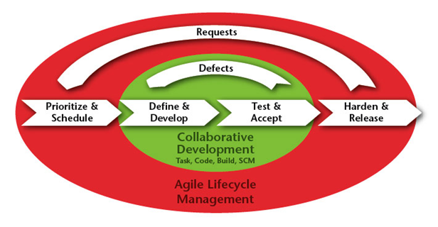

**GIT Management**

* For "Release" version, example, 8.6.1, use ***HEAD*** branch.
* For patch version, example: 8.6.0, use ***GlobalSight_8_6_0_Released*** branch.

**Development:**

* Development team lead will assign the work item to their team members.
* Developer will test their changes on their own GlobalSight test instance.

**Build and Test:**

* During development time, do weekly interim build to validate completed changes.
* At development end date, start full testing of all changes and full regression testing.

Note: Issue found during interim and full testing will be reported. Development will fix the issue and QA will validate it in next build iteration.

